Assignment 3 : Docker
One Git repo
Three branches:
- main (or master)
- 2026Q1
- 2026Q2
Jenkins Master (JM)
3 Jenkins Slaves
Each slave has Docker installed Use docker cp
Deploy: slave1 -- M, Q1, Q2 slave2 -- M, Q1, Q2 slave3 -- M, Q1, Q2
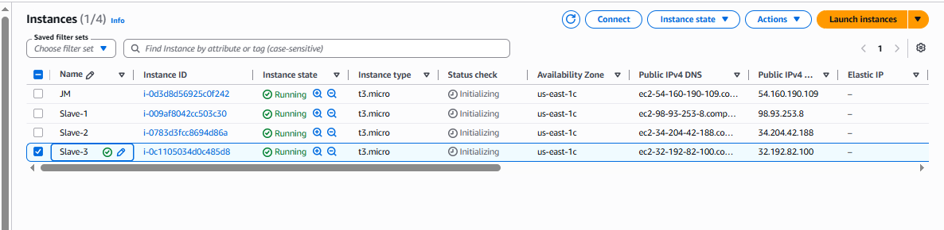

Install java in all machine :
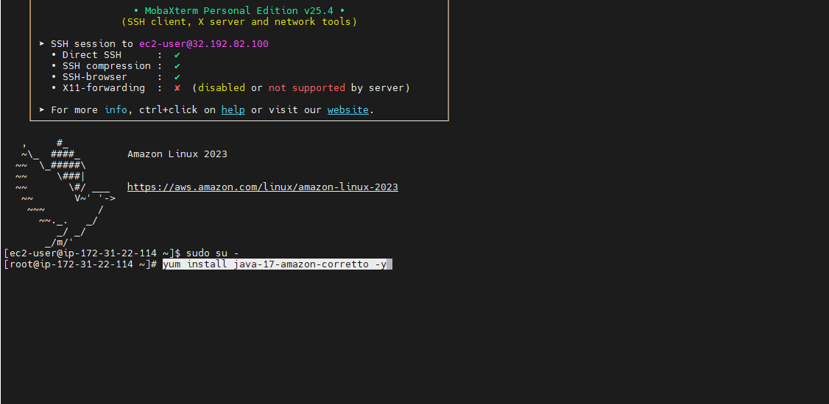

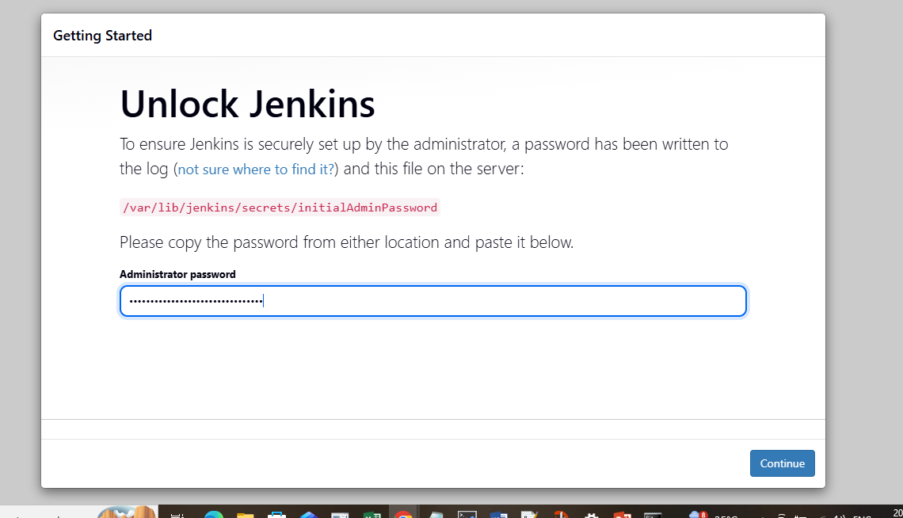

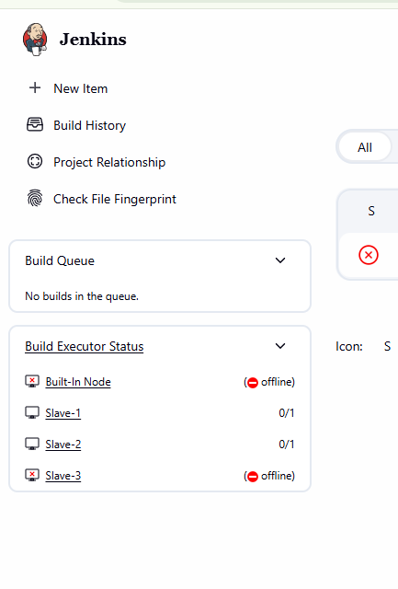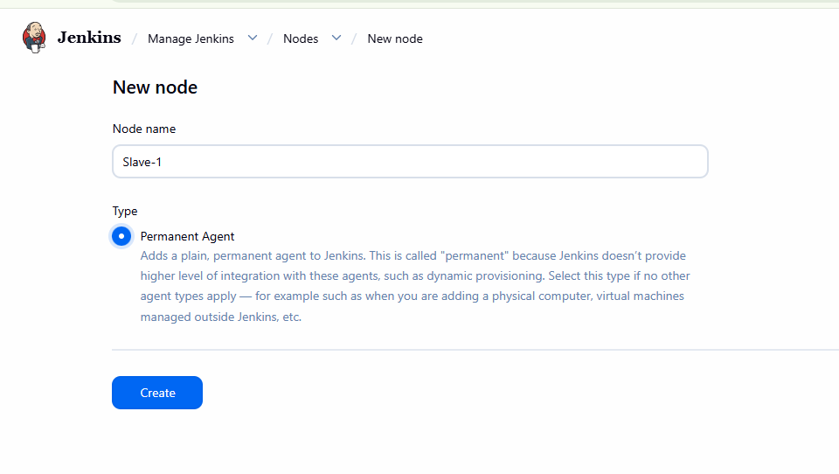

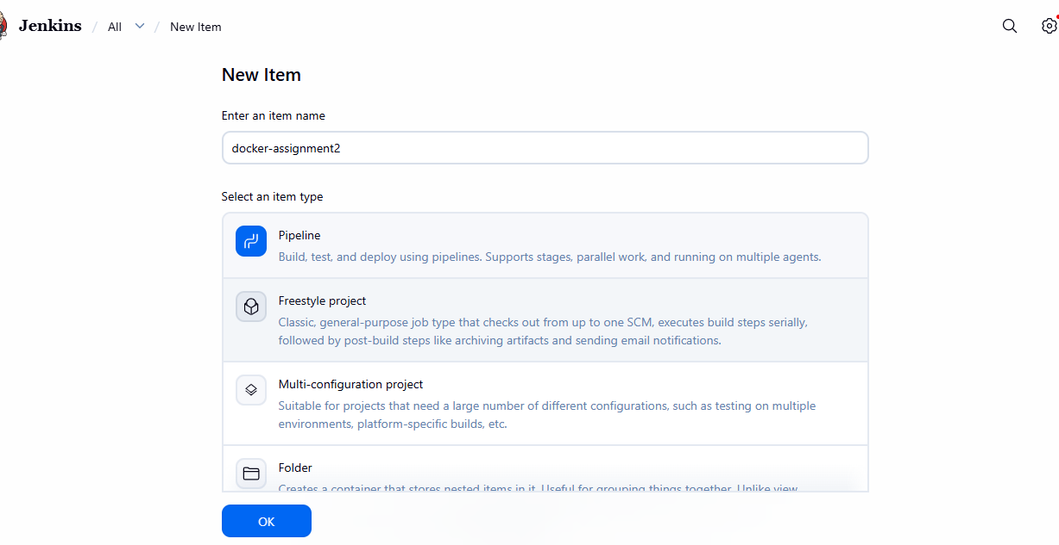
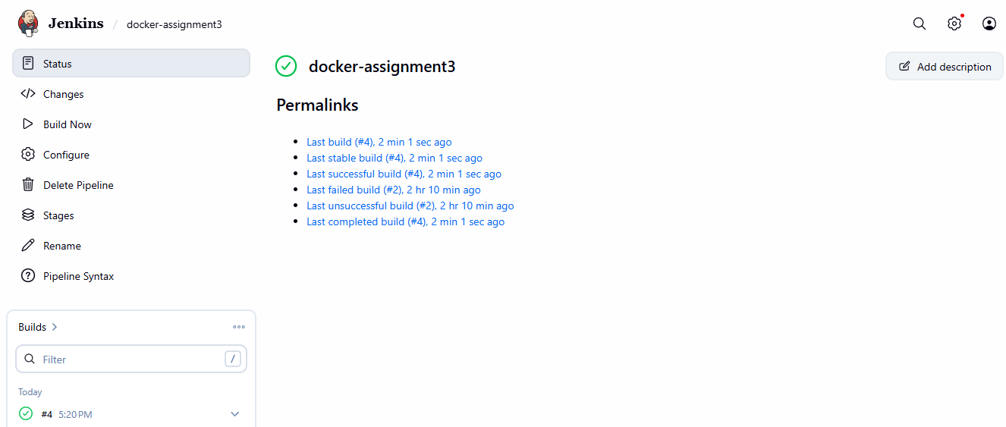

Slave : 1
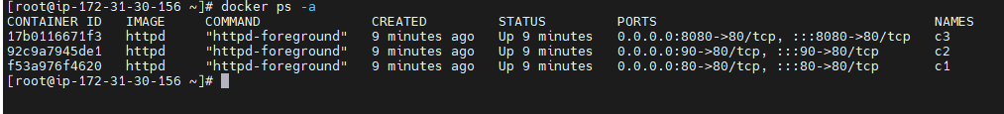
Port 80 :
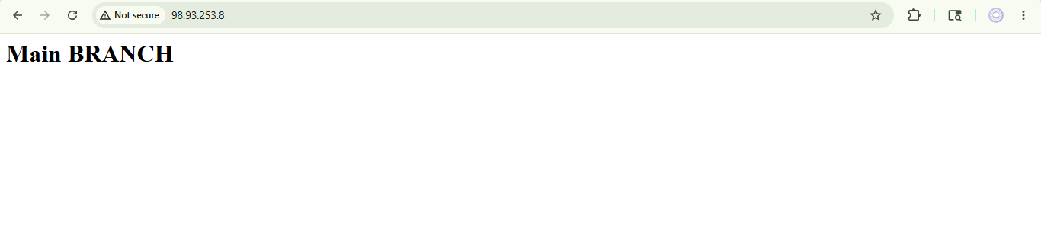Port 90:

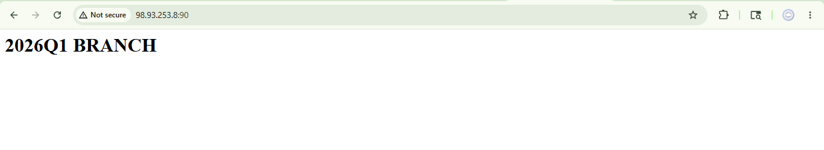
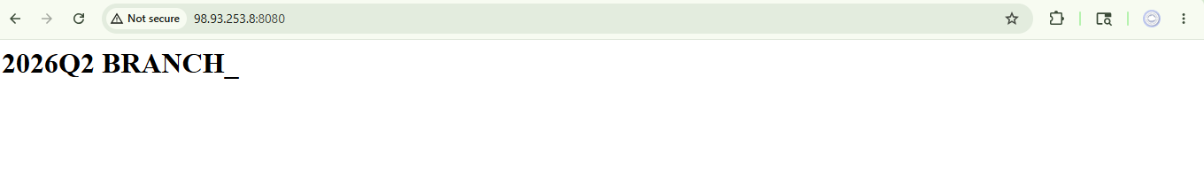
Slave :2
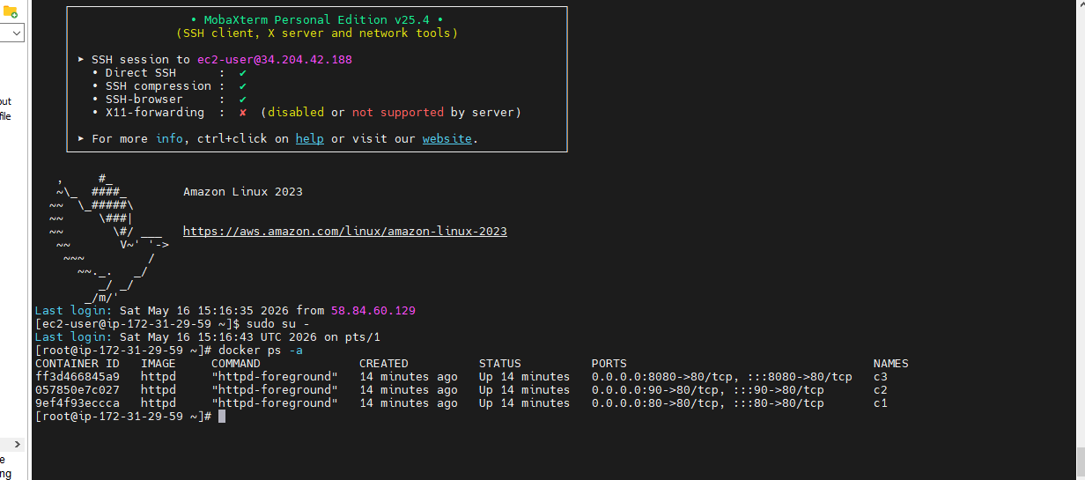

Port :80
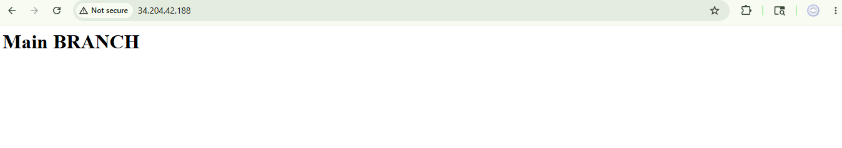

Port 90
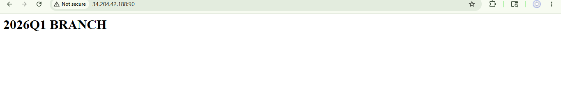
Port 8080:
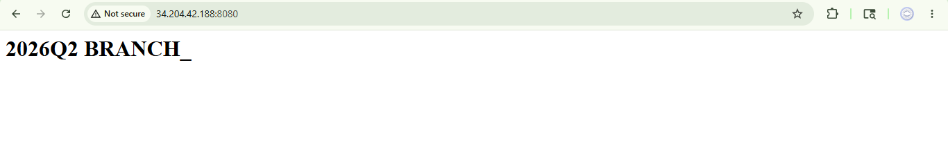

Slave 3:
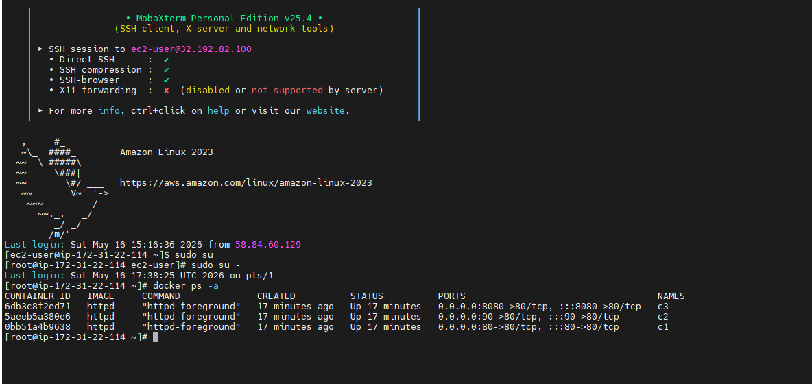
Slave 3 : with different port
Port 80 :
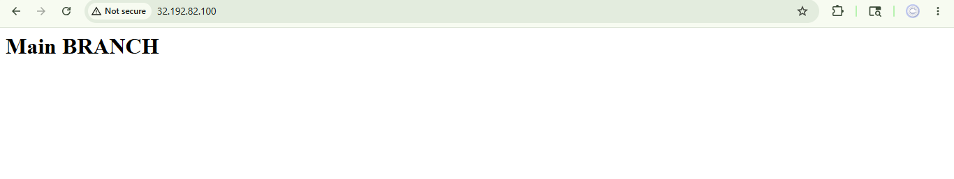
Port 90:
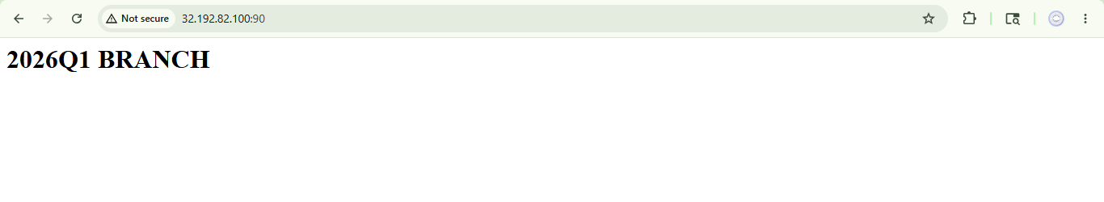
Port 8080
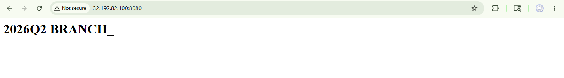

Syntax :
pipeline {

agent none

stages {

// ================= SLAVE 1 =================

stage('Deploy All on Slave1') {

agent { label 'Slave-1' }

steps {

sh '''

# MAIN
rm -rf repo
git clone -b main https://github.com/Pallavi-250598/Repo-1.git repo

docker rm -f c1 || true

docker run -dit --name c1 -p 80:80 httpd

docker cp repo/. c1:/usr/local/apache2/htdocs/

# Q1
rm -rf repo
git clone -b 2026Q1 https://github.com/Pallavi-250598/Repo-1.git repo

docker rm -f c2 || true

docker run -dit --name c2 -p 90:80 httpd

docker cp repo/. c2:/usr/local/apache2/htdocs/

# Q2
rm -rf repo
git clone -b 2026Q2 https://github.com/Pallavi-250598/Repo-1.git repo

docker rm -f c3 || true

docker run -dit --name c3 -p 8080:80 httpd

docker cp repo/. c3:/usr/local/apache2/htdocs/

'''
}
}

// ================= SLAVE 2 =================

stage('Deploy All on Slave2') {

agent { label 'Slave-2' }

steps {

sh '''

# MAIN
rm -rf repo
git clone -b main https://github.com/Pallavi-250598/Repo-1.git repo

docker rm -f c1 || true

docker run -dit --name c1 -p 80:80 httpd

docker cp repo/. c1:/usr/local/apache2/htdocs/

# Q1
rm -rf repo
git clone -b 2026Q1 https://github.com/Pallavi-250598/Repo-1.git repo

docker rm -f c2 || true

docker run -dit --name c2 -p 90:80 httpd

docker cp repo/. c2:/usr/local/apache2/htdocs/

# Q2
rm -rf repo
git clone -b 2026Q2 https://github.com/Pallavi-250598/Repo-1.git repo

docker rm -f c3 || true

docker run -dit --name c3 -p 8080:80 httpd

docker cp repo/. c3:/usr/local/apache2/htdocs/

'''
}
}

// ================= SLAVE 3 =================

stage('Deploy All on Slave3') {

agent { label 'Slave-3' }

steps {

sh '''

# MAIN
rm -rf repo
git clone -b main https://github.com/Pallavi-250598/Repo-1.git repo

docker rm -f c1 || true

docker run -dit --name c1 -p 80:80 httpd

docker cp repo/. c1:/usr/local/apache2/htdocs/

# Q1
rm -rf repo
git clone -b 2026Q1 https://github.com/Pallavi-250598/Repo-1.git repo

docker rm -f c2 || true

docker run -dit --name c2 -p 90:80 httpd

docker cp repo/. c2:/usr/local/apache2/htdocs/

# Q2
rm -rf repo
git clone -b 2026Q2 https://github.com/Pallavi-250598/Repo-1.git repo

docker rm -f c3 || true

docker run -dit --name c3 -p 8080:80 httpd

docker cp repo/. c3:/usr/local/apache2/htdocs/

'''
}
}
}
}
Command on slaves :
1 yum install java-17-amazon-corretto -y
2 yum install java-21-amazon-corretto.x86_64 -y
3 yum install git -y
4 yum install docker -y
5 systemctl enable docker
6 usermod -aG docker jenkins
7 sudo systemctl start docker
8 sudo systemctl status docker
9 sudo reboot
10 cat /etc/group | grep docker
11 sudo usermod -aG docker ec2-user
12 sudo reboot
13 docker ps -a
14 history

